Assignment 2 – Written

CSC 226

Ryan Woodward

V00857268

**1.**

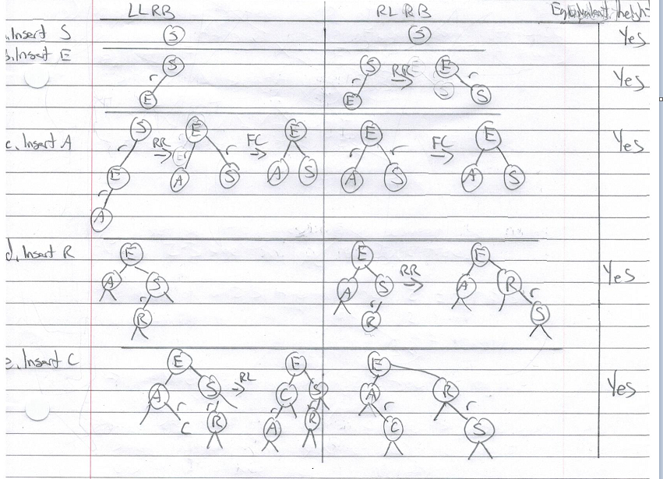

As we see with a left-leaning red black tree anytime there is a right-leaning link a rotateLeft is called in order to correct it. Or in the case of a right-leaning red-black tree a rotateRight is called if there is a left leaning link. We also see on the LLRB that if there are two red links in a row on the left side than a rotateRight is called. Similarly, in a RLRB tree if two red links occur in a row a rotateLeft is called. We can also see through the construction proof that the black edge height of each LLRB and RLRB tree remains equivalent throughout the construction of the tree.

**2.**

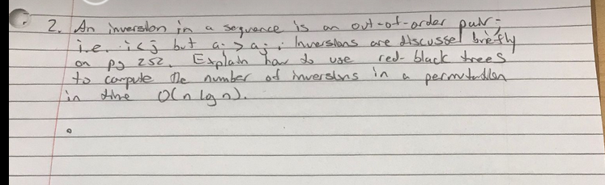

3.­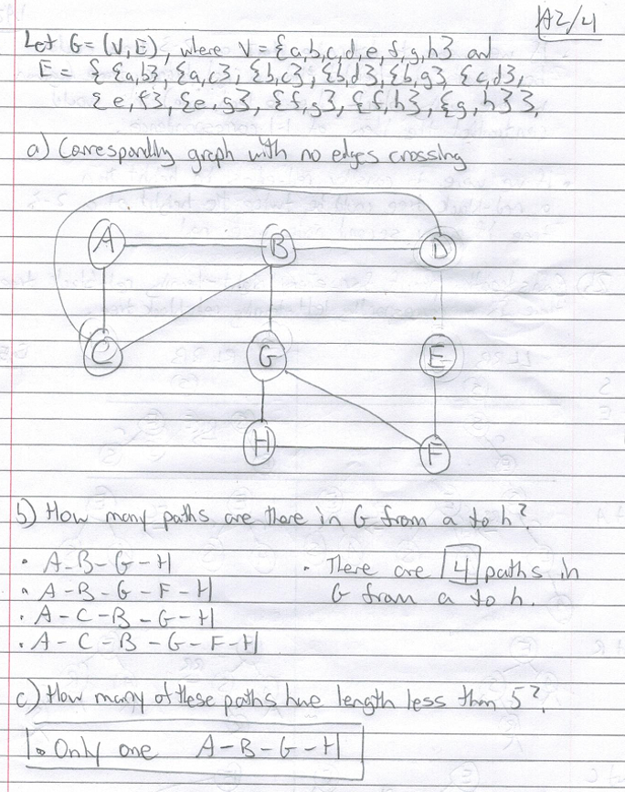

**4.**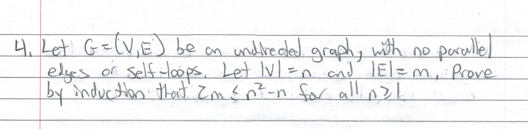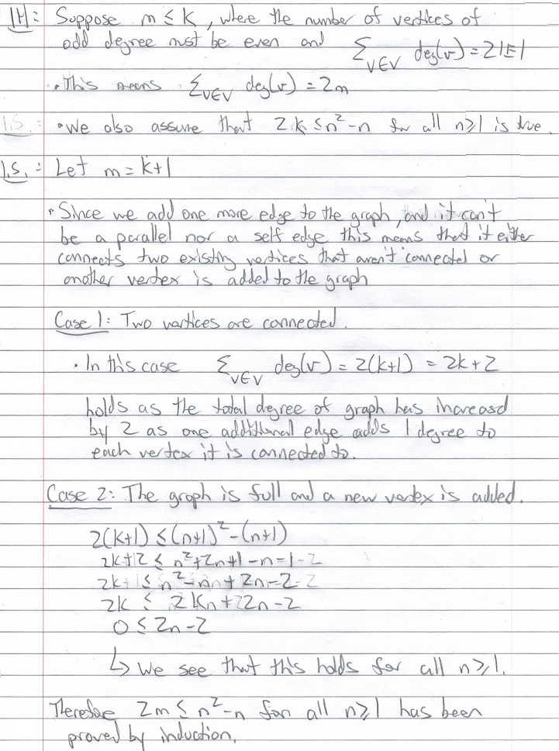

**5.**